E-commerce Project

Shopping store

Homepage

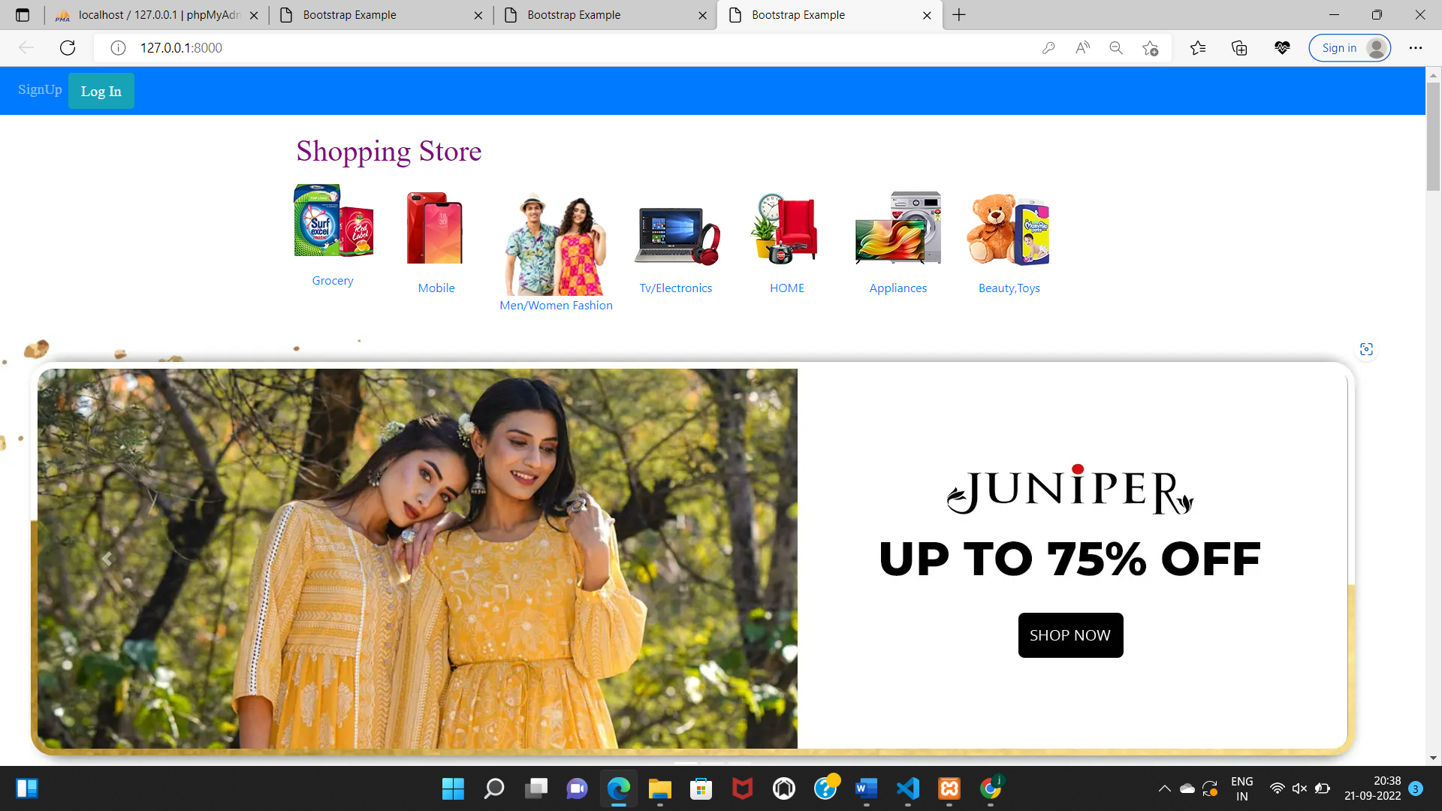

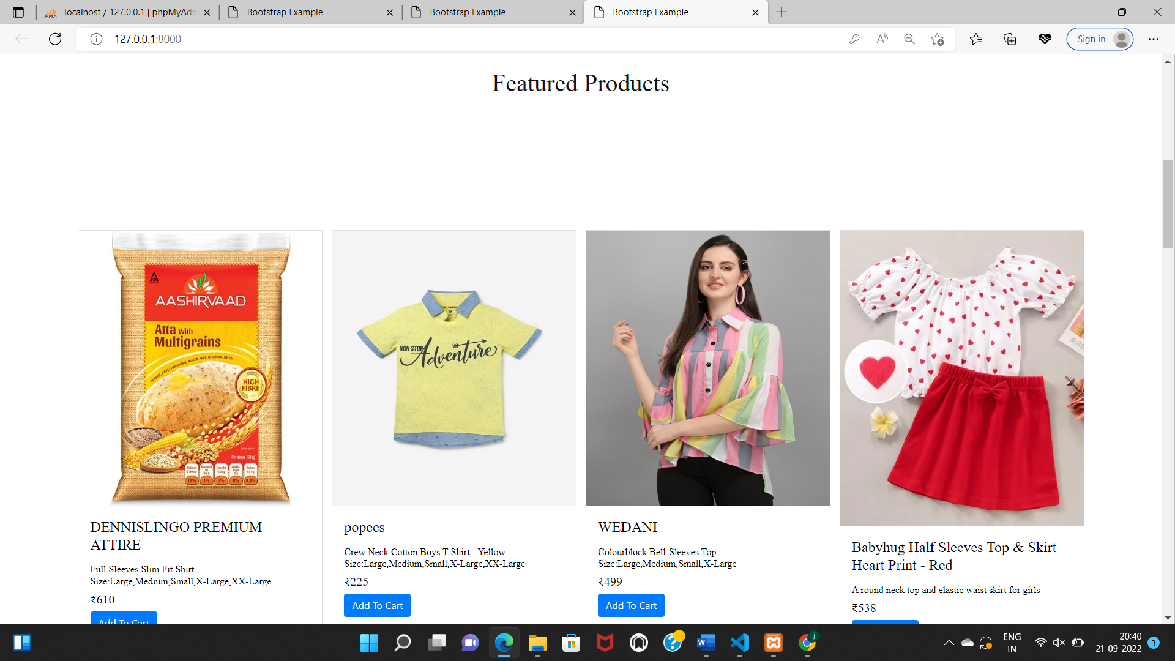

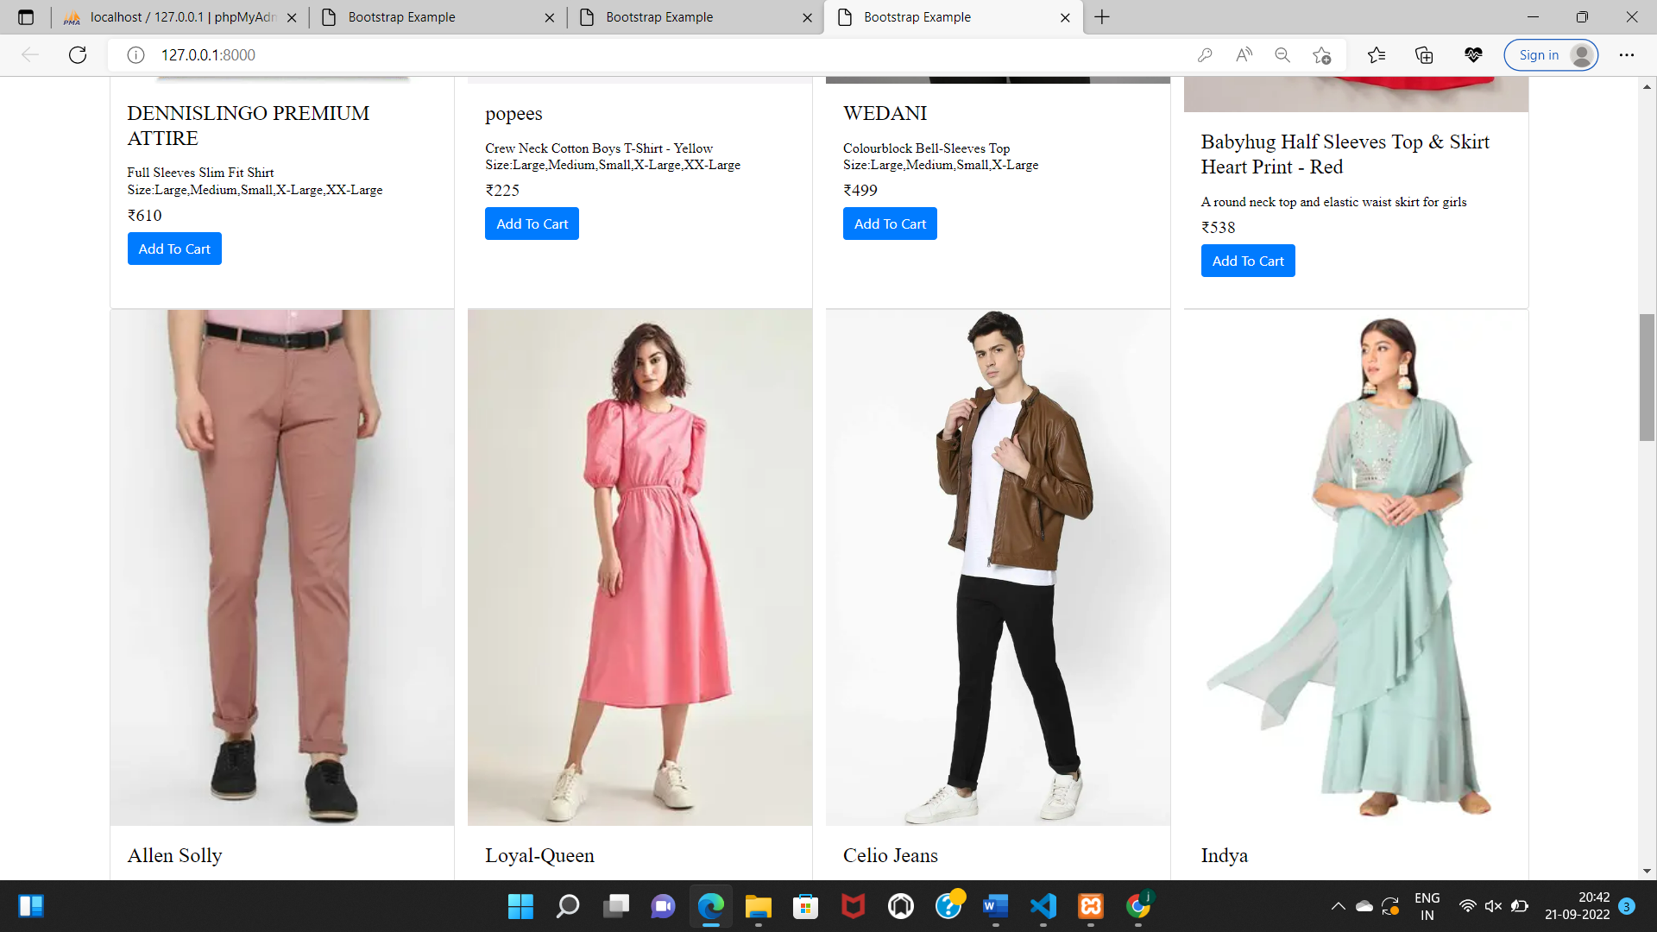

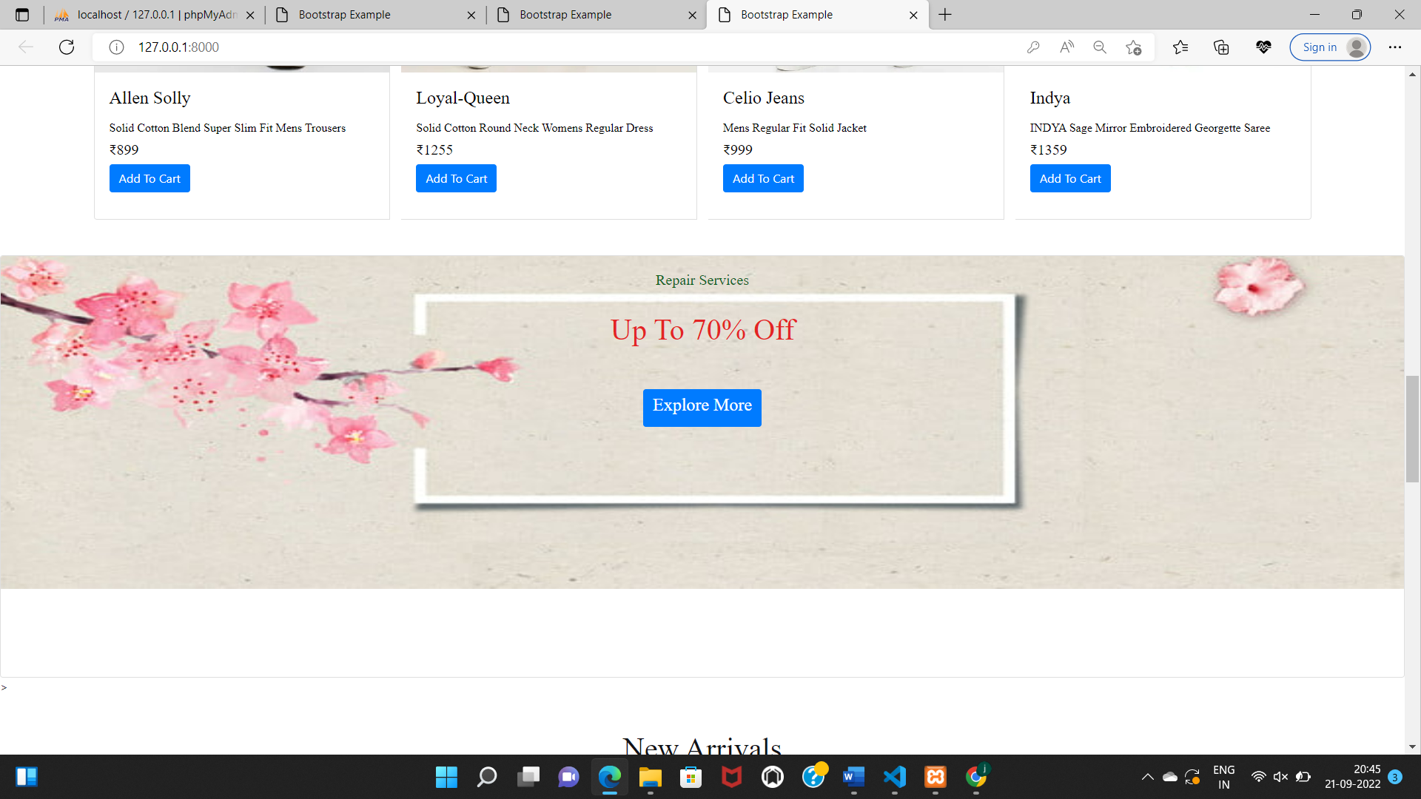

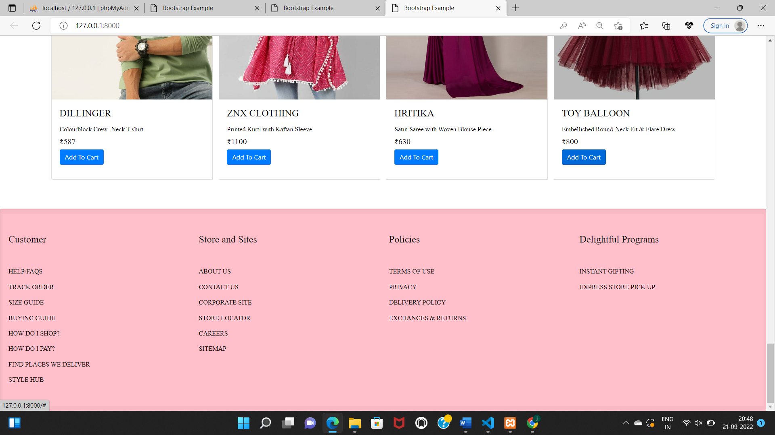

Signup form

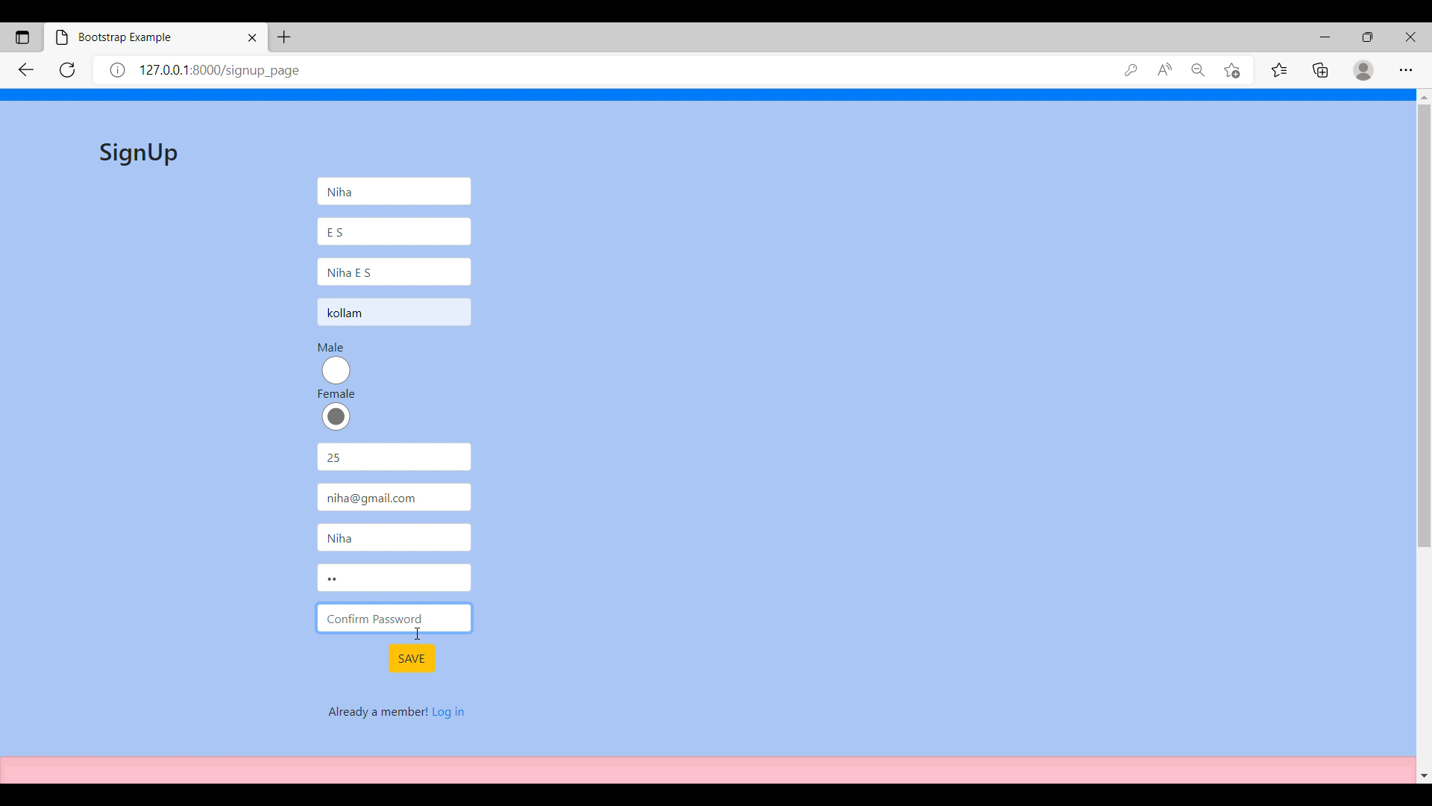

Login Form

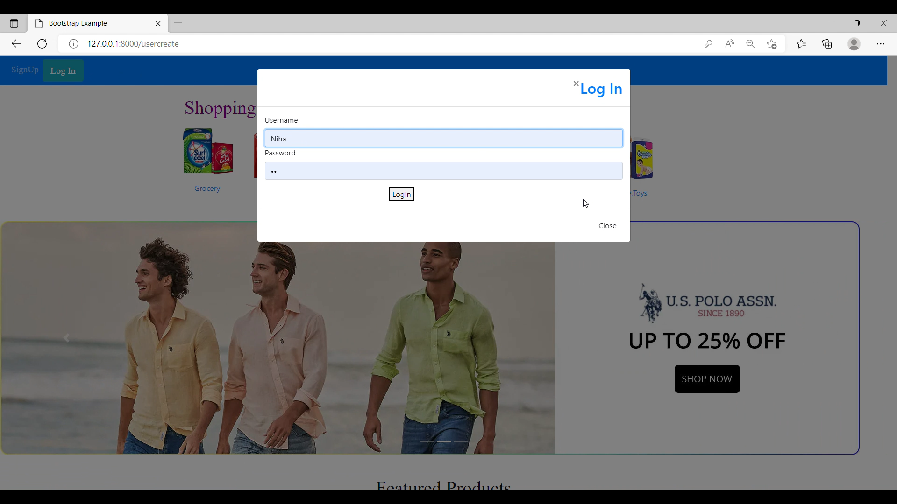

Customer Home Page

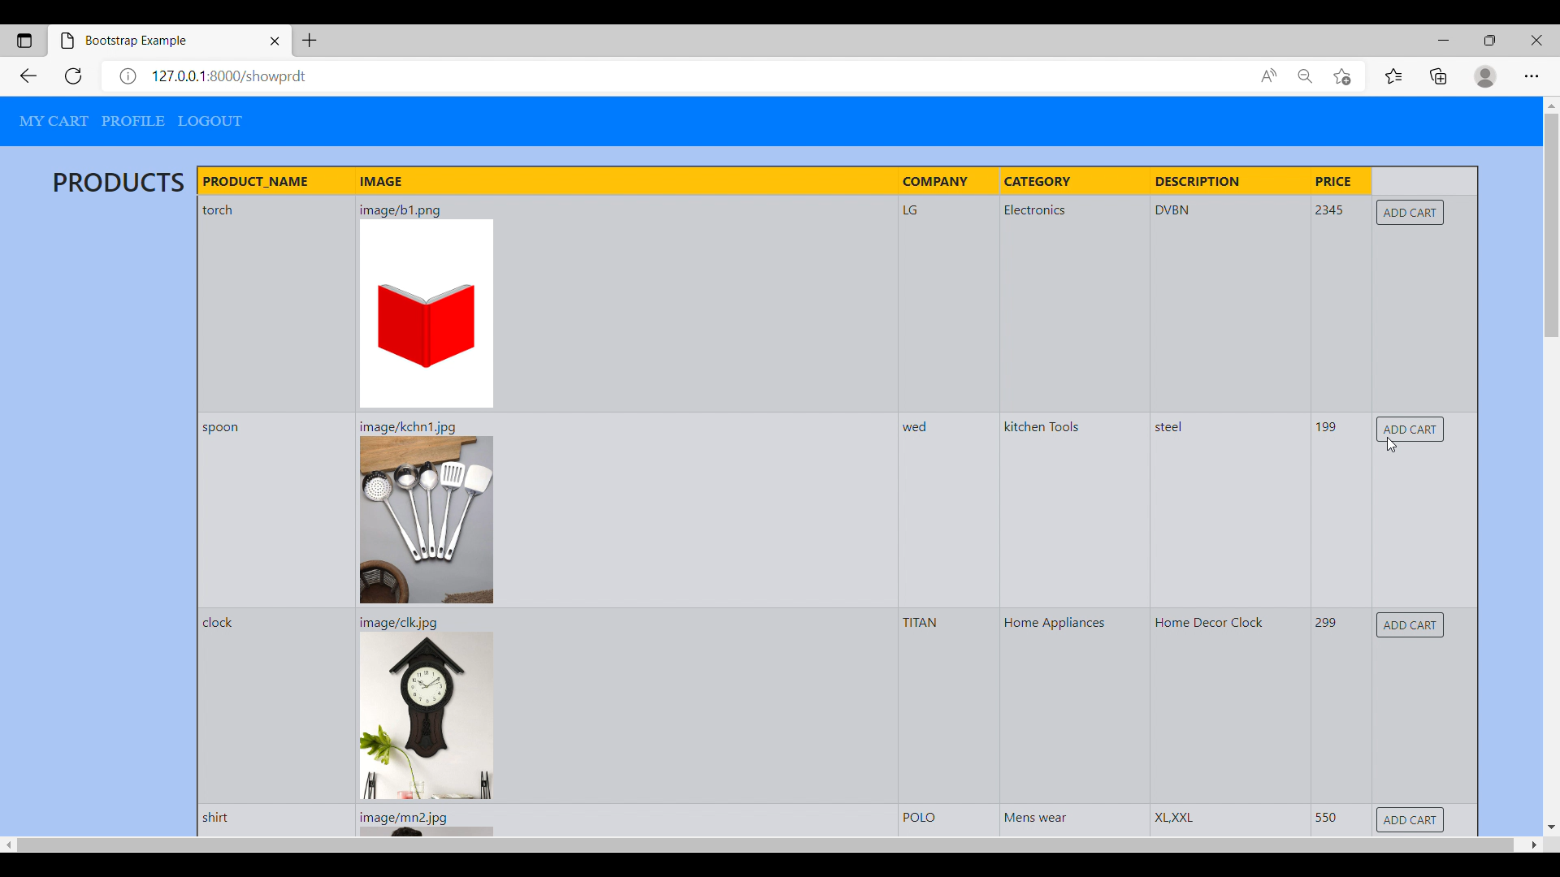

Product adding to cart

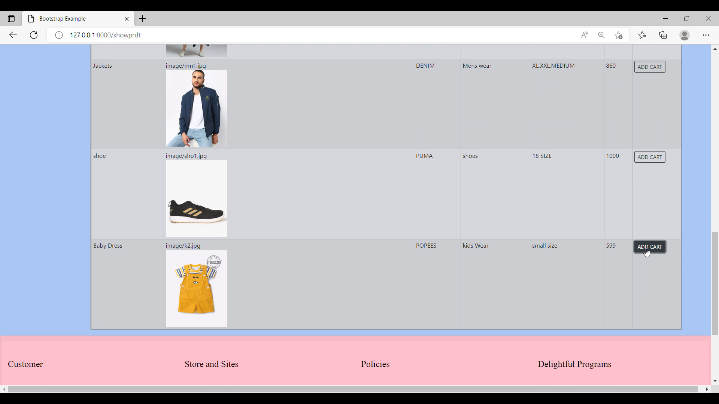

My cart page

It contains items save by customer

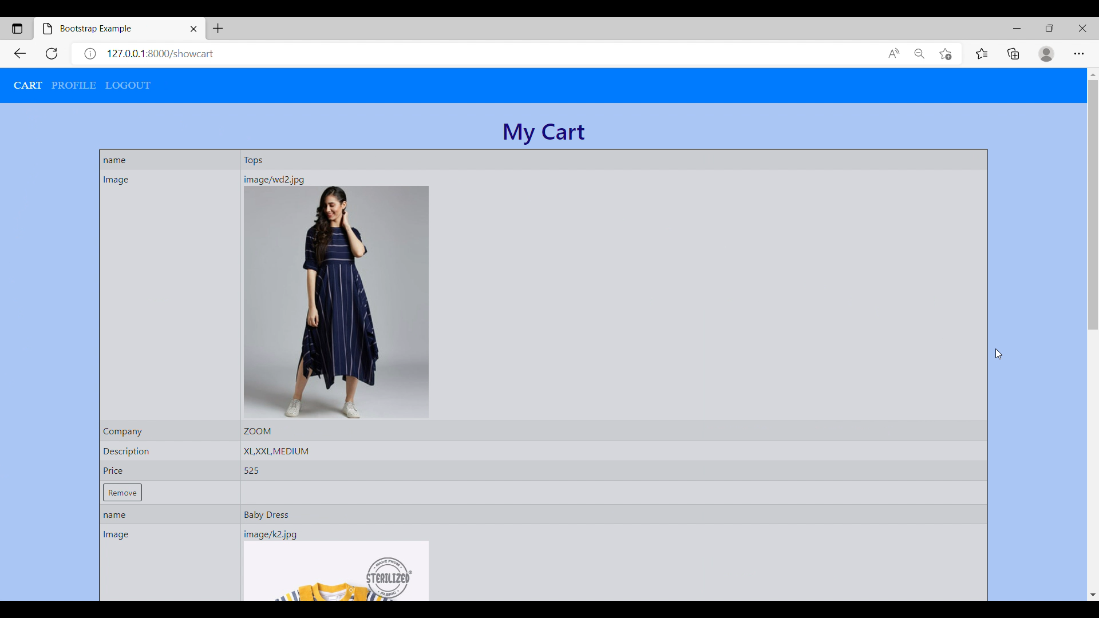

Customer profile viewing

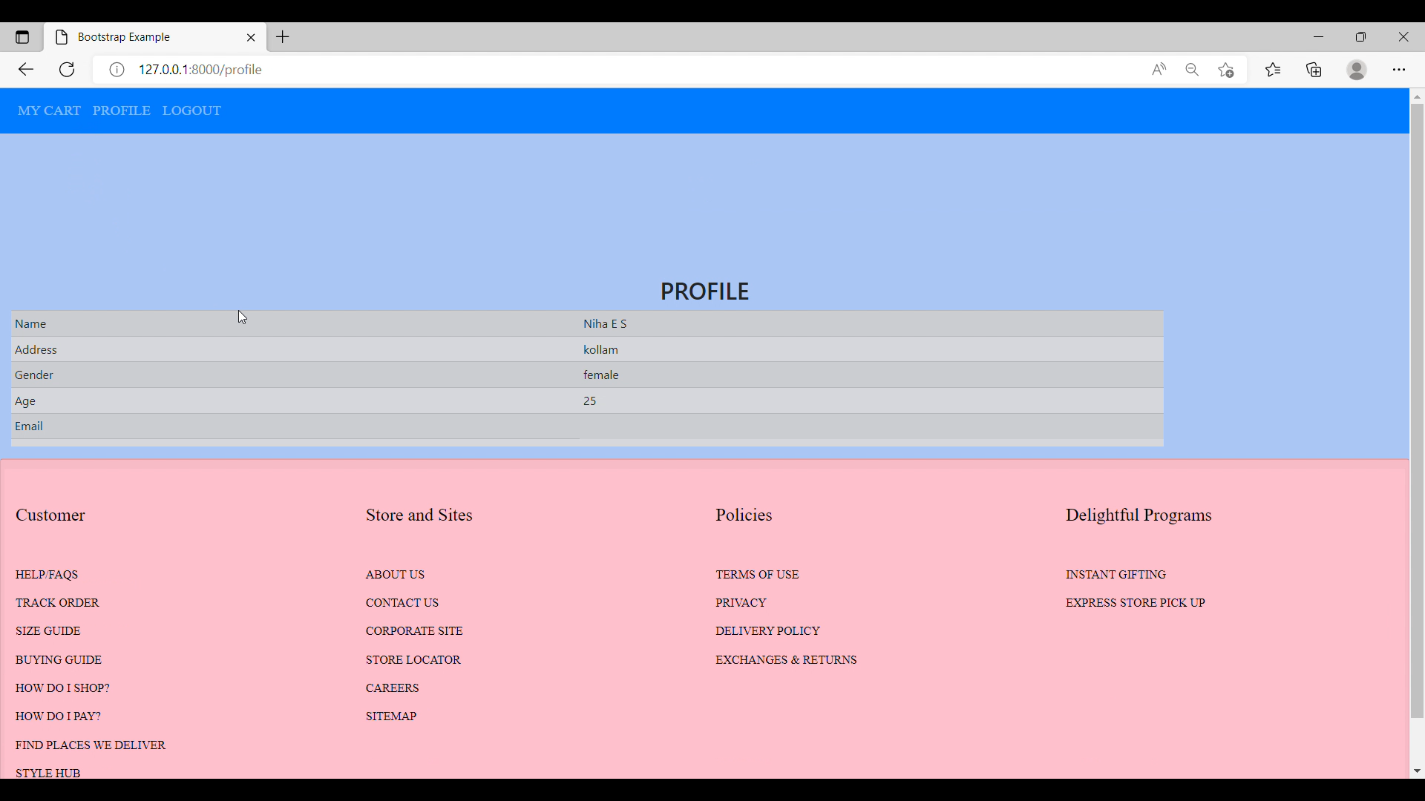

Admin Login

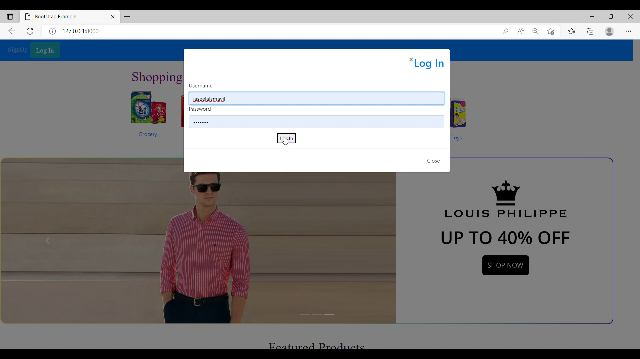

Admin adding Product Categories

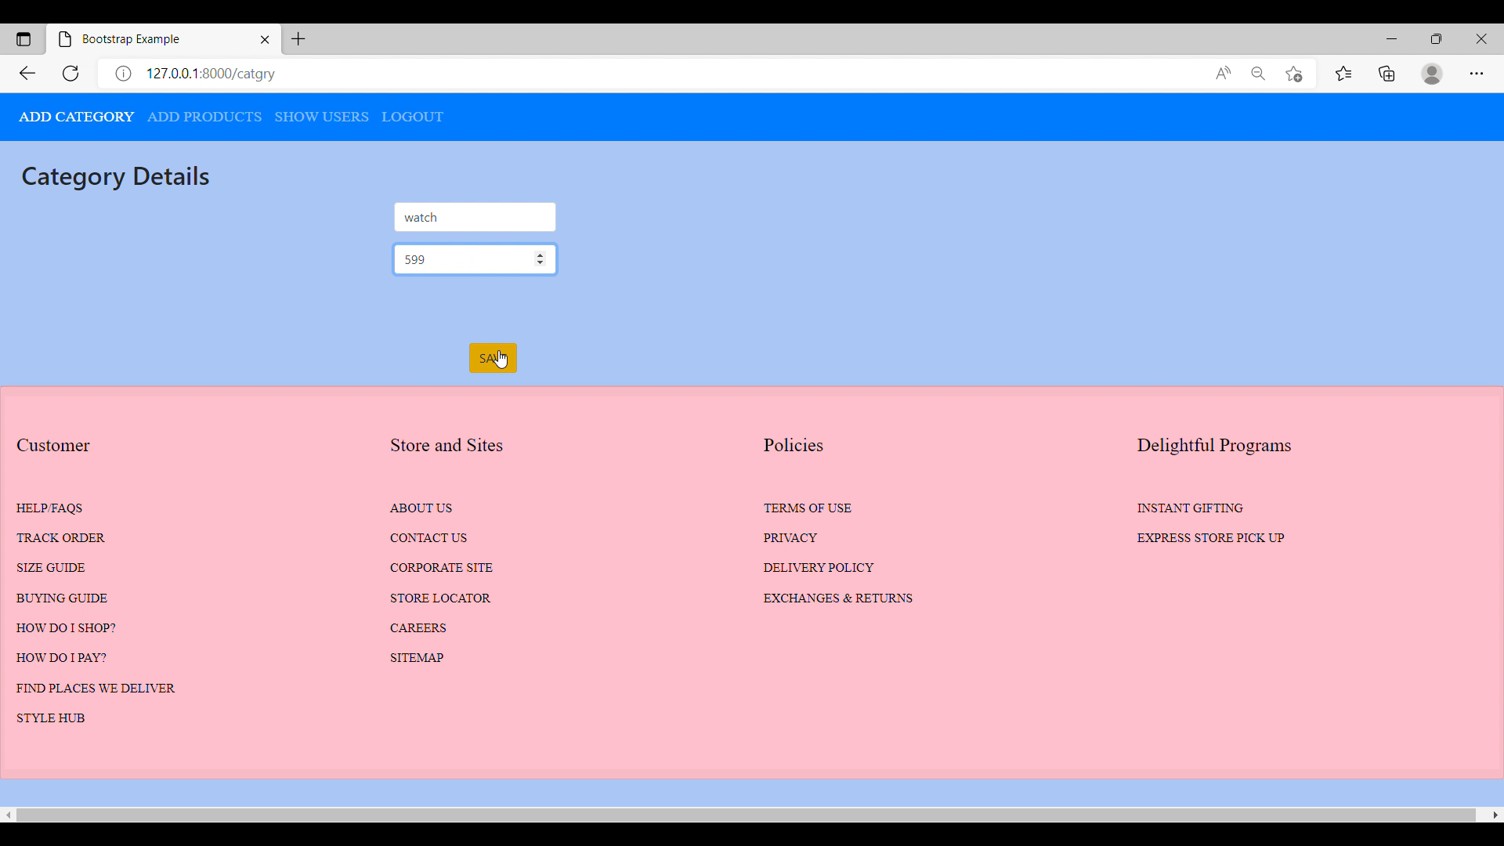

Admin adding Product Details

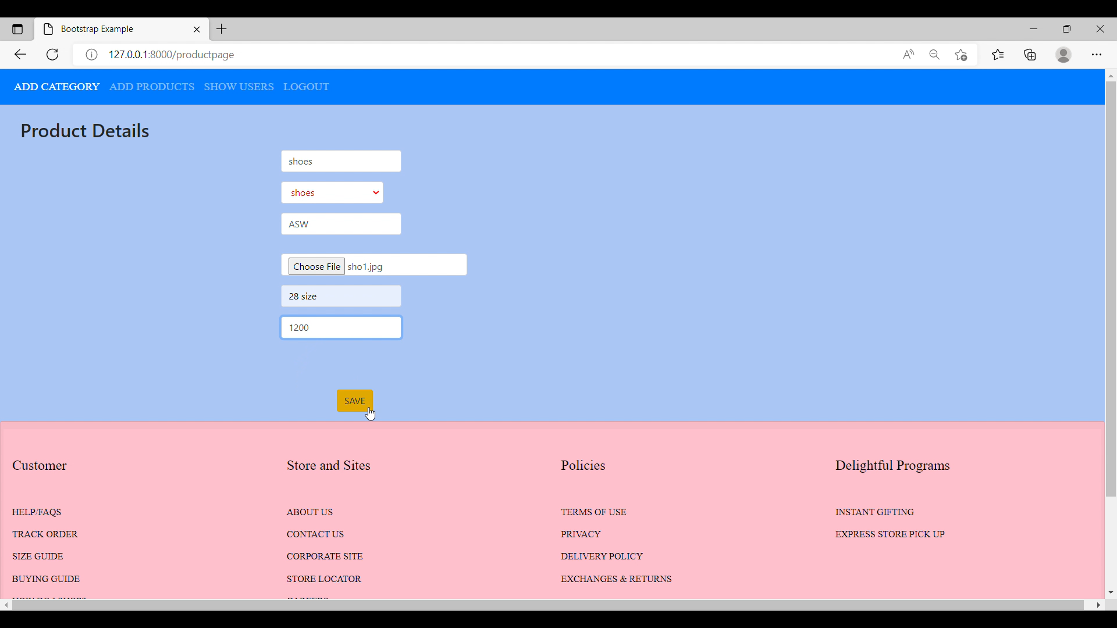

Admin shows Customer Details

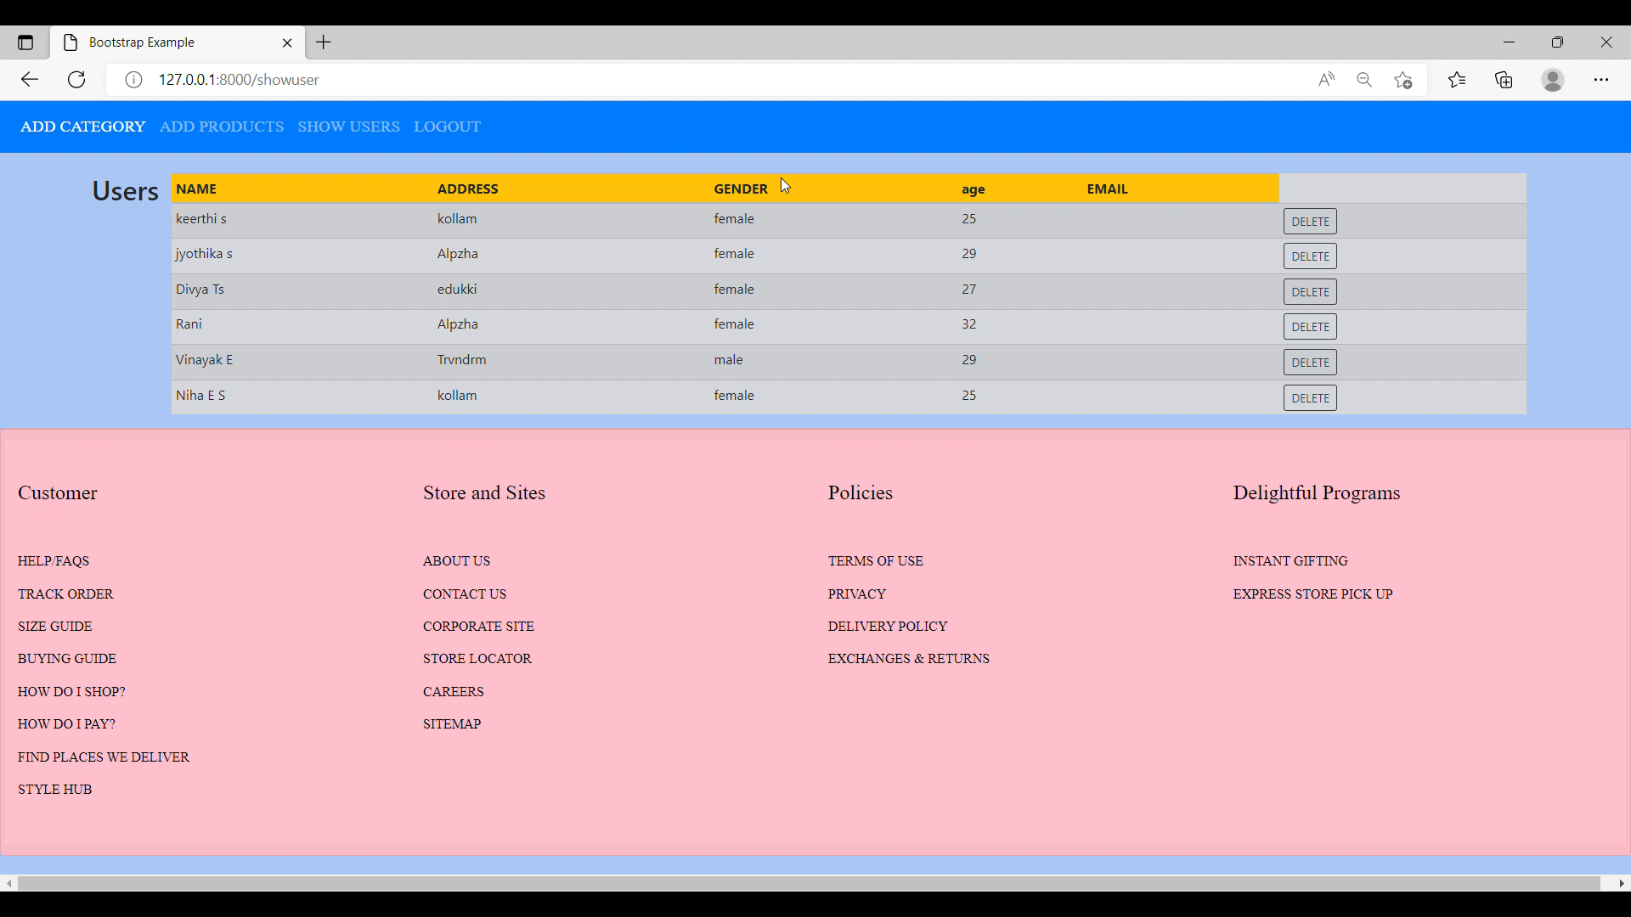

Views.py

from multiprocessing import context

from pydoc import describe

from django.contrib import messages

from django.shortcuts import render,redirect

from django.contrib.auth.models import User,auth

from shoppingApp.models import SCategory,SPrdts,SUserMember,SCart

from django.contrib.auth import authenticate,login,logout

from django.contrib.auth.decorators import login_required

# Create your views here.

def  home(request):

    return render(request,'home.html')

def adminhome(request):

    return render(request,'adminhome.html')

def userhome(request):

    return render(request,'userhome.html')

def signup_page(request):

    return render(request,'signup.html')

def usercreate(request):

    if request.method =='POST':

        firstname=request.POST['firstname']

        lastname=request.POST['lastname']

        fullname=request.POST['fullname']

        address=request.POST['address']

        gender=request.POST['gender']

        age=request.POST['age']

        email=request.POST['email']

        username=request.POST['username']

        password=request.POST['password']

        cpassword=request.POST['cpassword']

        if password==cpassword:

            if User.objects.filter(username=username).exists():

                messages.info(request,'This Username Already Exists!')

                return redirect('usercreate')

            else:

                user=User.objects.create_user(

                    first_name=firstname,

                    last_name=lastname,

                    email=email,

                    username=username,

                    password=password)

                user.save()

                ds=User.objects.get(id= user.id)

                udt=SUserMember(

                    fullname=fullname,

                    address=address,

                    gender=gender,

                    age=age,

                    user=ds)

                udt.save()

        else:

            print('Password is not Matching..')

            return redirect('usercreate')

    return render(request,'home.html')

def SLogin(request):

    if request.method=='POST':

        username=request.POST['username']

        password=request.POST['password']

        user = auth.authenticate(username=username,password=password)

        if user is not None:

            if user.is_staff:

                auth.login(request,user)

                return redirect('adminhome')#adminhome

            else:

                auth.login(request,user)

                return redirect('showprdt')#index

        else:

            return redirect('SLogin')

    else:

        return redirect('home')#admin home

@login_required(login_url='SLogin')

def SLogout(request):

    if request.user.is_authenticated:

        auth.logout(request)

    return redirect('index')#

def catgry(request):

    return render(request,'addCatgry.html')

def addcatgry(request):

    if request.method== 'POST':

        catg=request.POST['category']

        sprice=request.POST['st_price']

        cgr=SCategory(category=catg,st_price=sprice)

        cgr.save()

        return redirect('adminhome')

def showcatg(request):

    if not request.user.is_staff:

        return redirect('usercreate')

    cgrs=SCategory.objects.all()

    return render(request,'addCatgry.html',{'cgr':cgrs})

def productpage(request):

    categs=SCategory.objects.all()

    return render(request,'addPrdts.html',{'categs':categs})

def add_prd(request):

    if request.method=='POST':

        pname=request.POST['pname']

        select=request.POST['category']

        category=SCategory.objects.get(id=select)

        company=request.POST['company']

        image=request.FILES.get('image')

        desc=request.POST['desc']

        price=request.POST['price']

        prd=SPrdts(pname=pname,category=category,company=company,image=image,desc=desc,price=price)

        prd.save()

        return redirect('adminhome')

def showuser(request):

    if not request.user.is_staff:

        return redirect('usercreate')

    suser=SUserMember.objects.all()

    return render(request,'showUser.html',{'suser':suser})

def delUser(request,id):

    if not request.user.is_staff:

        return redirect('usercreate')

    suser=SUserMember.objects.get(id=id)

    suser.delete()

    return redirect('showuser')

def profile(request):

    s=SUserMember.objects.get(user=request.user)

    return render (request,'profile.html',{'s':s})

def cat(request):

    return render(request,'viewCart.html')

@login_required(login_url='SLogin')

def add_cart(request,id):

    pnames=SPrdts.objects.get(id=id)

    dt=SCart.objects.create(pname=pnames,user=request.user)

    dt.save()

    return redirect('showprdt')

@login_required(login_url='SLogin')

def showcart(request):

    pnames=SCart.objects.filter(user=request.user)

    return render(request,'viewCart.html',{'pnames':pnames})

def removeItem(request,id):

    if  request.user.is_staff:

        return redirect('usercreate')

    scart=SCart.objects.get(id=id)

    scart.delete()

    return redirect('showcart')

def showprdt(request):

     pname=SPrdts.objects.all()

     return render(request,'viewPrdts.html',{'pname':pname})

Models.py

from unicodedata import category

from django.db import models

from django.contrib.auth.models import User

class SCategory(models.Model):

    category=models.TextField()

    st_price=models.IntegerField()

    def __str__(self):

        return self.category

class SPrdts(models.Model):

    category=models.ForeignKey(SCategory,on_delete=models.CASCADE,null=True)

    pname=models.TextField()

    company=models.TextField()

    image=models.ImageField(upload_to='image/',null=True)

    desc=models.TextField()

    price=models.IntegerField()

    def __str__(self):

        return self.category.category

class SUserMember(models.Model):

    user=models.ForeignKey(User,on_delete=models.CASCADE,null=True)

    fullname=models.TextField()

    address=models.TextField()

    gender=models.TextField()

    age=models.IntegerField()

    email=models.TextField()

    def __str__(self):

        return self.user.username

class SCart(models.Model):

    user=models.ForeignKey(User,on_delete=models.CASCADE,null=True)

    pname=models.ForeignKey(SPrdts,on_delete=models.CASCADE,null=True)